ISO 22301:2012(E) PDCA MODEL
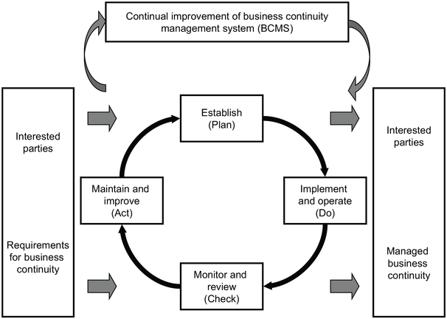
Plan  (Establish) | Establish business continuity policy, objectives, targets, controls, processes and procedures relevant to improving business continuity in order to deliver results that align with UON’s overall policies and objectives.
Do  (Implement and operate) | Implement and operate the business continuity policy, controls, processes and procedures.
Check  (Monitor and review) | Monitor and review performance against business continuity policy and objectives, report the results to management for review and determine and authorise actions for remediation and improvement.
Act  (Maintain and improve | Maintain and improve the BCMS by taking corrective action, based on the results of management review and reappraising the scope of the BCMS and business continuity policy and objectives.
Table 1 – Explanation of PDCA model

