INTERVIEW ON ASSESSMENT ITEMS PROCEDURE | 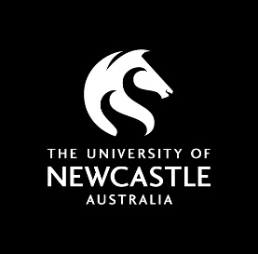
Appendix 2 – Sample Questions for Use in Interviews

Some questions that may be suitable for an Interview on an assessment item include:

- Your answer to question number “X”, [read the text of the question] was quite [brief/confusing/unexpected/interesting] – could you please explain what aspects of the course you drew on to arrive at this answer?

- Could you please explain how you arrived at the answer to question “X”, [read the text of the question]?
- You answered question “X”, [read the text of the question] by [read the answer]. What do you think you could add to this to improve your answer?

- Your answer to question “X” is unusual because it [doesn’t match other answers you have given/was not covered in the course/uses a different approach to what we covered in the course] – could you please tell us how you came to this [answer/response].

