INTERVIEW ON ASSESSMENT ITEMS PROCEDURE | 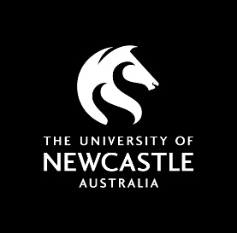
Appendix 1 – Statements for Inclusion in Course Outline

Course Outline
The following statement is included in the default Course Outline template:
Interviews on Assessment Items:
An Interview may be conducted in accordance with the Interview on Assessment Items Procedure. The purpose of the Interview is to verify the author of the material submitted in response to the assessment task and provide a quality assurance measure. In the event the Course Coordinator is not satisfied that the student’s oral responses are consistent with the work originally submitted, the matter will be referred to the Student Academic Conduct Officer. The Student Academic Conduct Officer will be responsible for reviewing the matter and initiating appropriate action under the Student Conduct Rule.

Task Instructions
Where a Course Coordinator wishes to provide an additional reminder to students for a specific task, the following information may be added to the task instructions in a course outline or within the University learning management system:
After you have submitted this task you may be required to undertake an Interview. The purpose of the Interview is to verify the author of the material submitted in response to the assessment task and provide a quality assurance measure. The Interview will be conducted by your Course Coordinator either in person or via video conference (e.g. Zoom, Skype, Collaborate) for approximately 15 minutes.
During this time, you may be asked to:
- clarify or explain your responses;
- provide additional information to responses; or
- answer additional questions to demonstrate your knowledge of a topic and/or concept.
You will be contacted via email by your Course Coordinator if you are selected to take part in an Interview.

