Checklist: Quality Standards for Technology Enhanced Learning (TEL) (Blended and Online)

This checklist incorporates the principles set out by the TEQSA HES Framework and provides the UON quality standards for the design of the online learning environment, including the key design features that need to be included in all course sites to provide students with an engaging quality learning experience.
A useful resource listing quality pedagogy and design standards for teaching and learning, including online learning, is also the Higher Education Quality Matters (QM) Specific Review Standards

Feature | Quality Standard Required
Course Menu and Site Structure
Site Structure | Provide students with information about  - online learning  - site navigation  - access to resources (technical support and Blackboard student resources link)
Weekly Banner | Ensure all details are entered into the weekly banner
Communication with Students
Introduction | Welcome video and corresponding written welcome message  Learner support guide is provided for navigating the online course
Communication | Communication expectations are clearly stated in relation to tutor/teacher response times, online discussions and other forms of interaction  Utilise analytics for learner interventions at critical times during teaching periods i.e. initial student Blackboard access, assessment submission etc.
Announcements | Key dates in teaching period and reminders for assessment are communicated clearly via the use of announcements
Contacts | Academic teaching staff contact information and available times for consultation
Facilitating Student Participation and Engagement
Asynchronous Collaboration | Discussion forum or other form of asynchronous collaborative communication is made available
Synchronous Collaboration | Any synchronous discussion/presentation for collaborative communication needs to be embedded into the course site
Course Content and Learning Activities
Students with disability and/or mental health conditions
It is a legislative requirement that all university courses incorporate accessible design principles in the layout and structure of course content and learning activities. More information can be found here to guide you in making sure your course is accessible for all students including those with a disability.
Copyright
It is essential that all Blackboard sites are copyright compliant. Further information and resources on copyright for teaching can be found here and copyright information specific to your course site can be found here.
Course Outline | Published to site before course site goes live  Weekly schedule in table-form included in same area
Course Modules/Materials | Folders organised in weekly or topic modules with corresponding with course schedule
 | multiple digital assets are utilised where appropriate for course content (such as videos, podcasts, images, quizzes, simulations)
 | Individual learning activities/student application facilitated through the use of a mix of activities (such as quizzes, reflection exercises (journals), readings, field exercises, blogs)
 | Course Readings organised via library’s Course Readings site. Step-by-step instructions can be found here.
Additional Materials | Provide links to additional readings and relevant discipline resources to support and guide student learning  Include a Frequently Asked Questions (FAQs) resource for the course and materials
Support Resources | Provide information and links to university student support services – Student Central resources, AccessAbility, Learning Advisors etc.
Assessment Practice
(Submission, grading and feedback, online assessments, grades)
Assessment Items | Provide a table in this tab outlining all course assessments and due dates above the assessment folders  Assessment information is provided in the relevant assessment area and is aligned with assessment numbering and naming in Course Outline  Include all assessment information in each corresponding assessment folder, including:  relevant learning outcome(s); assessment description; due date and submission instructions (i.e. Turnitin); grading rubric; and feedback timing and process  Students are provided with guidance and support in the use of online assessment tools  Where possible, students are provided with practice opportunities for formal assessment tasks (e.g. online tests).  Provide a link to Support Resources
Assessment Submission | Assessments are submitted via Turnitin or other online method  Students are provided with clear information about how to submit their work and information about the importance of academic integrity
Assessment Grading and Feedback | Assessments are graded with feedback and grades recorded in the course site (i.e. using Turnitin Feedback Studio or Inline Grading Tool and Grade Centre for results)  Make use of analytics to communicate success and outcomes to students

Course Site Evaluation
To evaluate and improve the course, make use of the Course Reflection documents located in the appendix of the Course Management and Assessment Procedure Manual.

Supporting UON Policies and Resources:
- Course Management and Assessment Procedure Manual
- Program Management Procedure Manual
- New Education Framework and Curriculum design principles

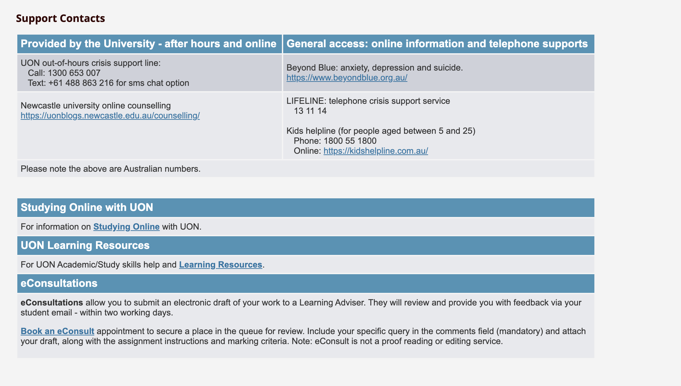

Academic Support
https://www.newcastle.edu.au/current-students/support/academic

Studying Online
https://www.newcastle.edu.au/study/new-students/orientation/studying-online

eConsult booking
https://careerhub.newcastle.edu.au/students/login?ReturnUrl=%2fs%2fcentre-for-teaching-and-learning%2fappointments%2fapp%2ftopic%2f13%3fsiteId%3d5

